**Introduction:**

The objective of the Truss Design Project was to construct a truss that would be able to withstand a specific loading range while abiding by the various requirements and restrictions of the assignment.

For roughly the first 7 weeks the team needed to gain knowledge about simple engineering concepts before constructing the truss. Some of these concepts were solving problems regarding equilibrium, axial, and flexural stresses/strains, administering experiments to analyze data and identify where the error occurred and using arithmetic tools such as Excel to numerically find solutions to problems and display these solutions graphically. An example of one of these modules is Module 3 where we measured the compression of the tubular brass to determine different end conditions.This is graphed in the attachment below (A11).

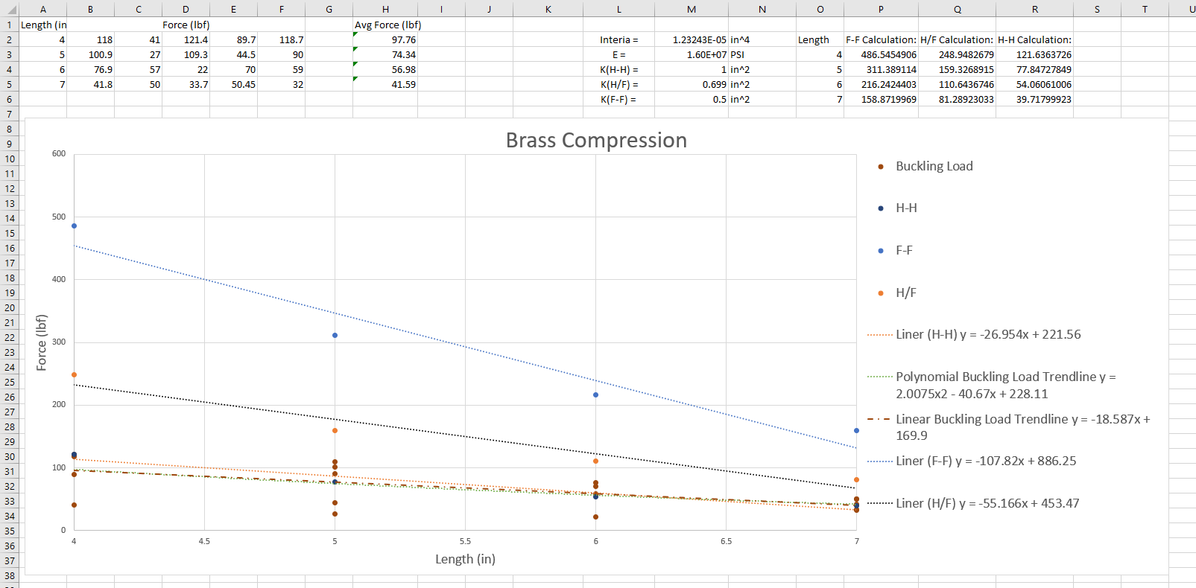

By learning these concepts the team was able to understand terms such as elastic deformation, elongation to failure, resilience, modulus of elasticity, etc. and it helped the group study which materials and shapes would result in the best design.  
 There were several requirements and restrictions the group had to abide by while designing the truss. When designing trusses with the Truss Analyzer program, each member had to use the following estimated linear buckling equation: -35x + 350. The load was only going to be applied to the top joint, not on any of the members in which case the project would not be a truss anymore because a truss consists of only two force members, where each member experiences no forces in between. The team's design was constructed using brass tubes and was limited to a height less than or equal to 4 inches and a width of 15 inches exactly. The truss had to support a load of 325 lb and no more than 500 lb, and had to be created using 72 inches of brass tubes or less. At each joint, a gusset had to be soldered on. However, at each edge on the bottom of the truss, as well as the top center of the truss, the team had to double gusset the joints for more stability. It was advised that the design did not have too many members meeting at a joint as it could cause complications when soldering. Overall, the specifications of the project made the team have to devise a logical plan to complete the task in time.

This plan started week 6-7 when each team member created individual truss designs. Then, the group got together, analyzing each design, checking for a variety of factors such as theoretical max loading, material length, strength to length ratio, and difficulty of assembly. The first week after choosing the design the group decided to construct, a plan was created to execute this design and the group discussed week by week goals that needed to be accomplished. The team was split into two groups of two, where the first group outlined a sketch of the design and cut the brass tubes accordingly, while the other group prepared ideas on how to solder the truss as well as practice soldering four brass tubes together. By splitting the team to accomplish a certain goal it made it easy for the team to focus on one task rather than worry about every step of the design. For a more descriptive breakdown of work, look at this attachment below (A1).

|  |  |
| --- | --- |
| Work Breakdown | |
| Truss Designs | Individual Designs-  Trevor Dawideit  Kayla Gorrell  Darren George  Jonathan Joshua  Final Design-  Trevor Dawideit  Sketch-  Kayla Gorrell |
| Fabrication | Cut and Sand-  Kayla Gorrell  Trevor Dawideit  Soldering-  Darren George  Jonathan Joshua |
| Oral Report | Objective-  Darren George  Requirements-  Jonathan Joshua  Design-  Kayla Gorrell  Testing/Final Evaluation-  Trevor Dawideit |
| Written Report | Abstract/Title Page/ToC-  Kayla Gorrell  Introduction-  Darren George  Jonathan Joshua  Discussion-  Kayla Gorrell  Trevor Dawideit  Conclusion-  Trevor Dawideit |
| Project Management | Kayla Gorrell |

Preparation with cutting and sanding members of the bridge took one whole class, and then the group spent two weeks to solder all the members together. In the end, the group beat the time projected to take, allowing the team to test the truss one week early. Overall, the scheduling plan made was effective in making sure each member knew what needed to be accomplished, kept the team aware of the time left to complete the truss, and ultimately allowed the team to finish with ample time left over to discuss explanations for the truss’s results as well as ways to improve the design given the opportunity to redo this project.

**Discussion:**

There were 3 essential steps to the design process: planning, designing, and fabrication. Given the requirements, the team members all made individual trusses. Using these trusses, a final design was chosen and a truss was fabricated off that design.

The designing process was a lot of trial and error implementing ideas learned from the first weeks in class. At first, all team members created individual designs to share ideas for how the truss should be designed. The program used was Truss Analyzer. Using the linear buckling equation for the truss, y=-35x+350, the program was able to determine the max load, total length, member length, and etc. The program was a tool used to create these designs with instant expected results which gave the team an idea if the team members were heading in the right direction with the designs.

The final design created was a combination of 2 of the individual designs. The first individual design (A2) below had a max load of 327.8, a length of 61.25”, and a strength to length ratio of 5.35. This design has the smallest total length out of the individual designs.

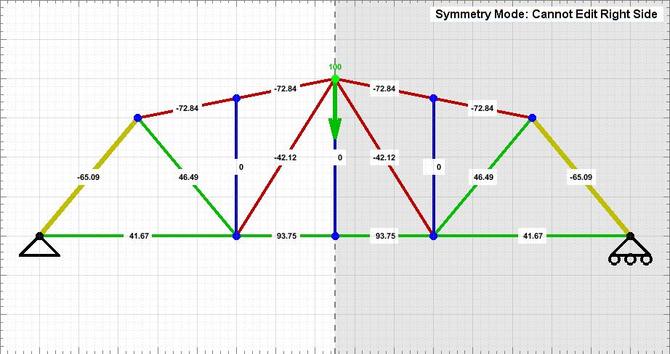

The appeal of this design is that it has two main solder joints on the base of the truss which can be ideal when trying to reduce the amount of total length of the truss. This was important for the truss to have because of the 72” brass limit and there would be extra material incase of a mistake. It was worth the risk of soldering multiple members to one joint. The other individual design (A3) used to create the final design is the image below.

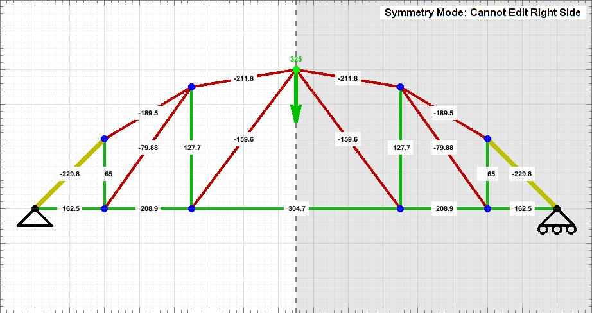

This design held the highest load out of all the individual designs. Its max load was 355 lbs and total length was 62.17”. What made this design more idealistic is that there is all members are holding some type of weight and that the outer frame is in an arc instead of jagged angles to create a better flow of weight distribution. Furthermore, this design had a higher strength to length ratio at 5.71. Using these two influences, the designing of the final design commenced and this was the result (A4).

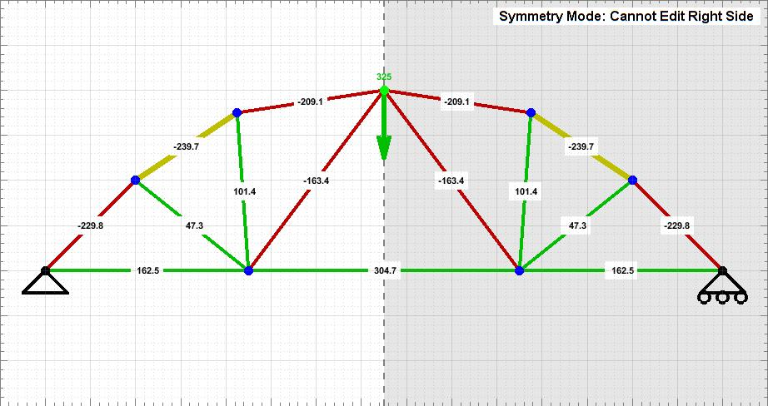

This was created by taking the second individual design and changing the base joints from 4 different joints to only 2 like in the first design. This was done because the team chose to optimize the trusses strength to length ratio. By using less joints the team was able to lower the trusses length by 6.11” to a total length of 56.06”. This lowered the strength by a 8.98 lbs making its max load 346.02 lbs. By doing this, the trusses strength to length ratio was increased by .47 making its strength to length ratio to 6.18.

Below is an in depth analysis of all designs created using the program Truss Analyzer (A5).

|  |  |  |  |
| --- | --- | --- | --- |
| Design | Picture of Truss | Max Load, Length, Strength to Length Ratio | Analysis |
| Kayla’s Individual Design |  | 327.8 lbs  61.25 in  5.35 | Pros of the design is that it has a small total length giving it a better strength to length ratio. Cons of the design is how it holds only the minimum and that there are members that don’t support any force, therefore a waste. |
| Trevor’s Individual Design |  | 355 lbs  62.17 in  5.71 | Pros of this design is its ability to hold so much while keeping length low. The arch design distributes weight seamlessly and the strength to length ratio is ideal. The cons of this design are the multiple connections with the base, causing excess length to be used. |
| Darren’s Individual Design |  | 350 lbs  79.1 in  4.42 | Pros of this design is the ability to hold 25 lbs more than the minimum. The cons are that it uses over the maximum amount of length, it has a low strength to length ratio and there’s a lot of joint connections that gives a lot of opportunity to make mistakes. |
| Jonathan’s Individual Design |  | 300.3 lbs  69.95 in  4.29 | The pro of this design is that it uses less than the maximum length of 72 in. The cons are that the design doesn’t hold at least 325 lbs, the strength to length ratio is not ideal, and there’s a lot of joint connections. |
| Final Design |  | 346.2 lbs  56.06 in  6.18 | Pros of this design is that it meets all requirements with room for error. Implementing the two main joints (from the first design) on the base kept total length low and the arch design (from the second design) distributed weight through all the members. The one con is that 5 member joints are hard to solder and the angles need to be accurate to ensure the success of the truss. |

The largest fabrication concern was getting the brass tubing to stay still while soldering. The team considered two options: having one person wear gloves and try to hold the brass members in place or placing a brick on top of the tubing to hold it down. It was decided that using a brick would be the best idea because it holds the tubing in place better than a person can. The other fabrication concern was how to apply the solder. The team decided to create small circular pellets of solder that could be placed on top of the joint for easy positioning and melting of the solder.

**Conclusions and Recommendations:**

The group's truss held less weight than expected. The truss was designed to hold 346.2 lbs but the actual build only held 300.2 lbs which is 13.29% less than the designed strength. The most probable cause for this failure is due to how the pieces were soldered during construction. Making double gussets proved to be a difficult task which resulted in multiple failed attempts to get the second brass strip soldered on properly. As seen in attachment A6 there was solder that ended up between the strip and the brass tubing. Furthermore, the fact that the team had to keep reheating the brass in that area could have weakened the material.

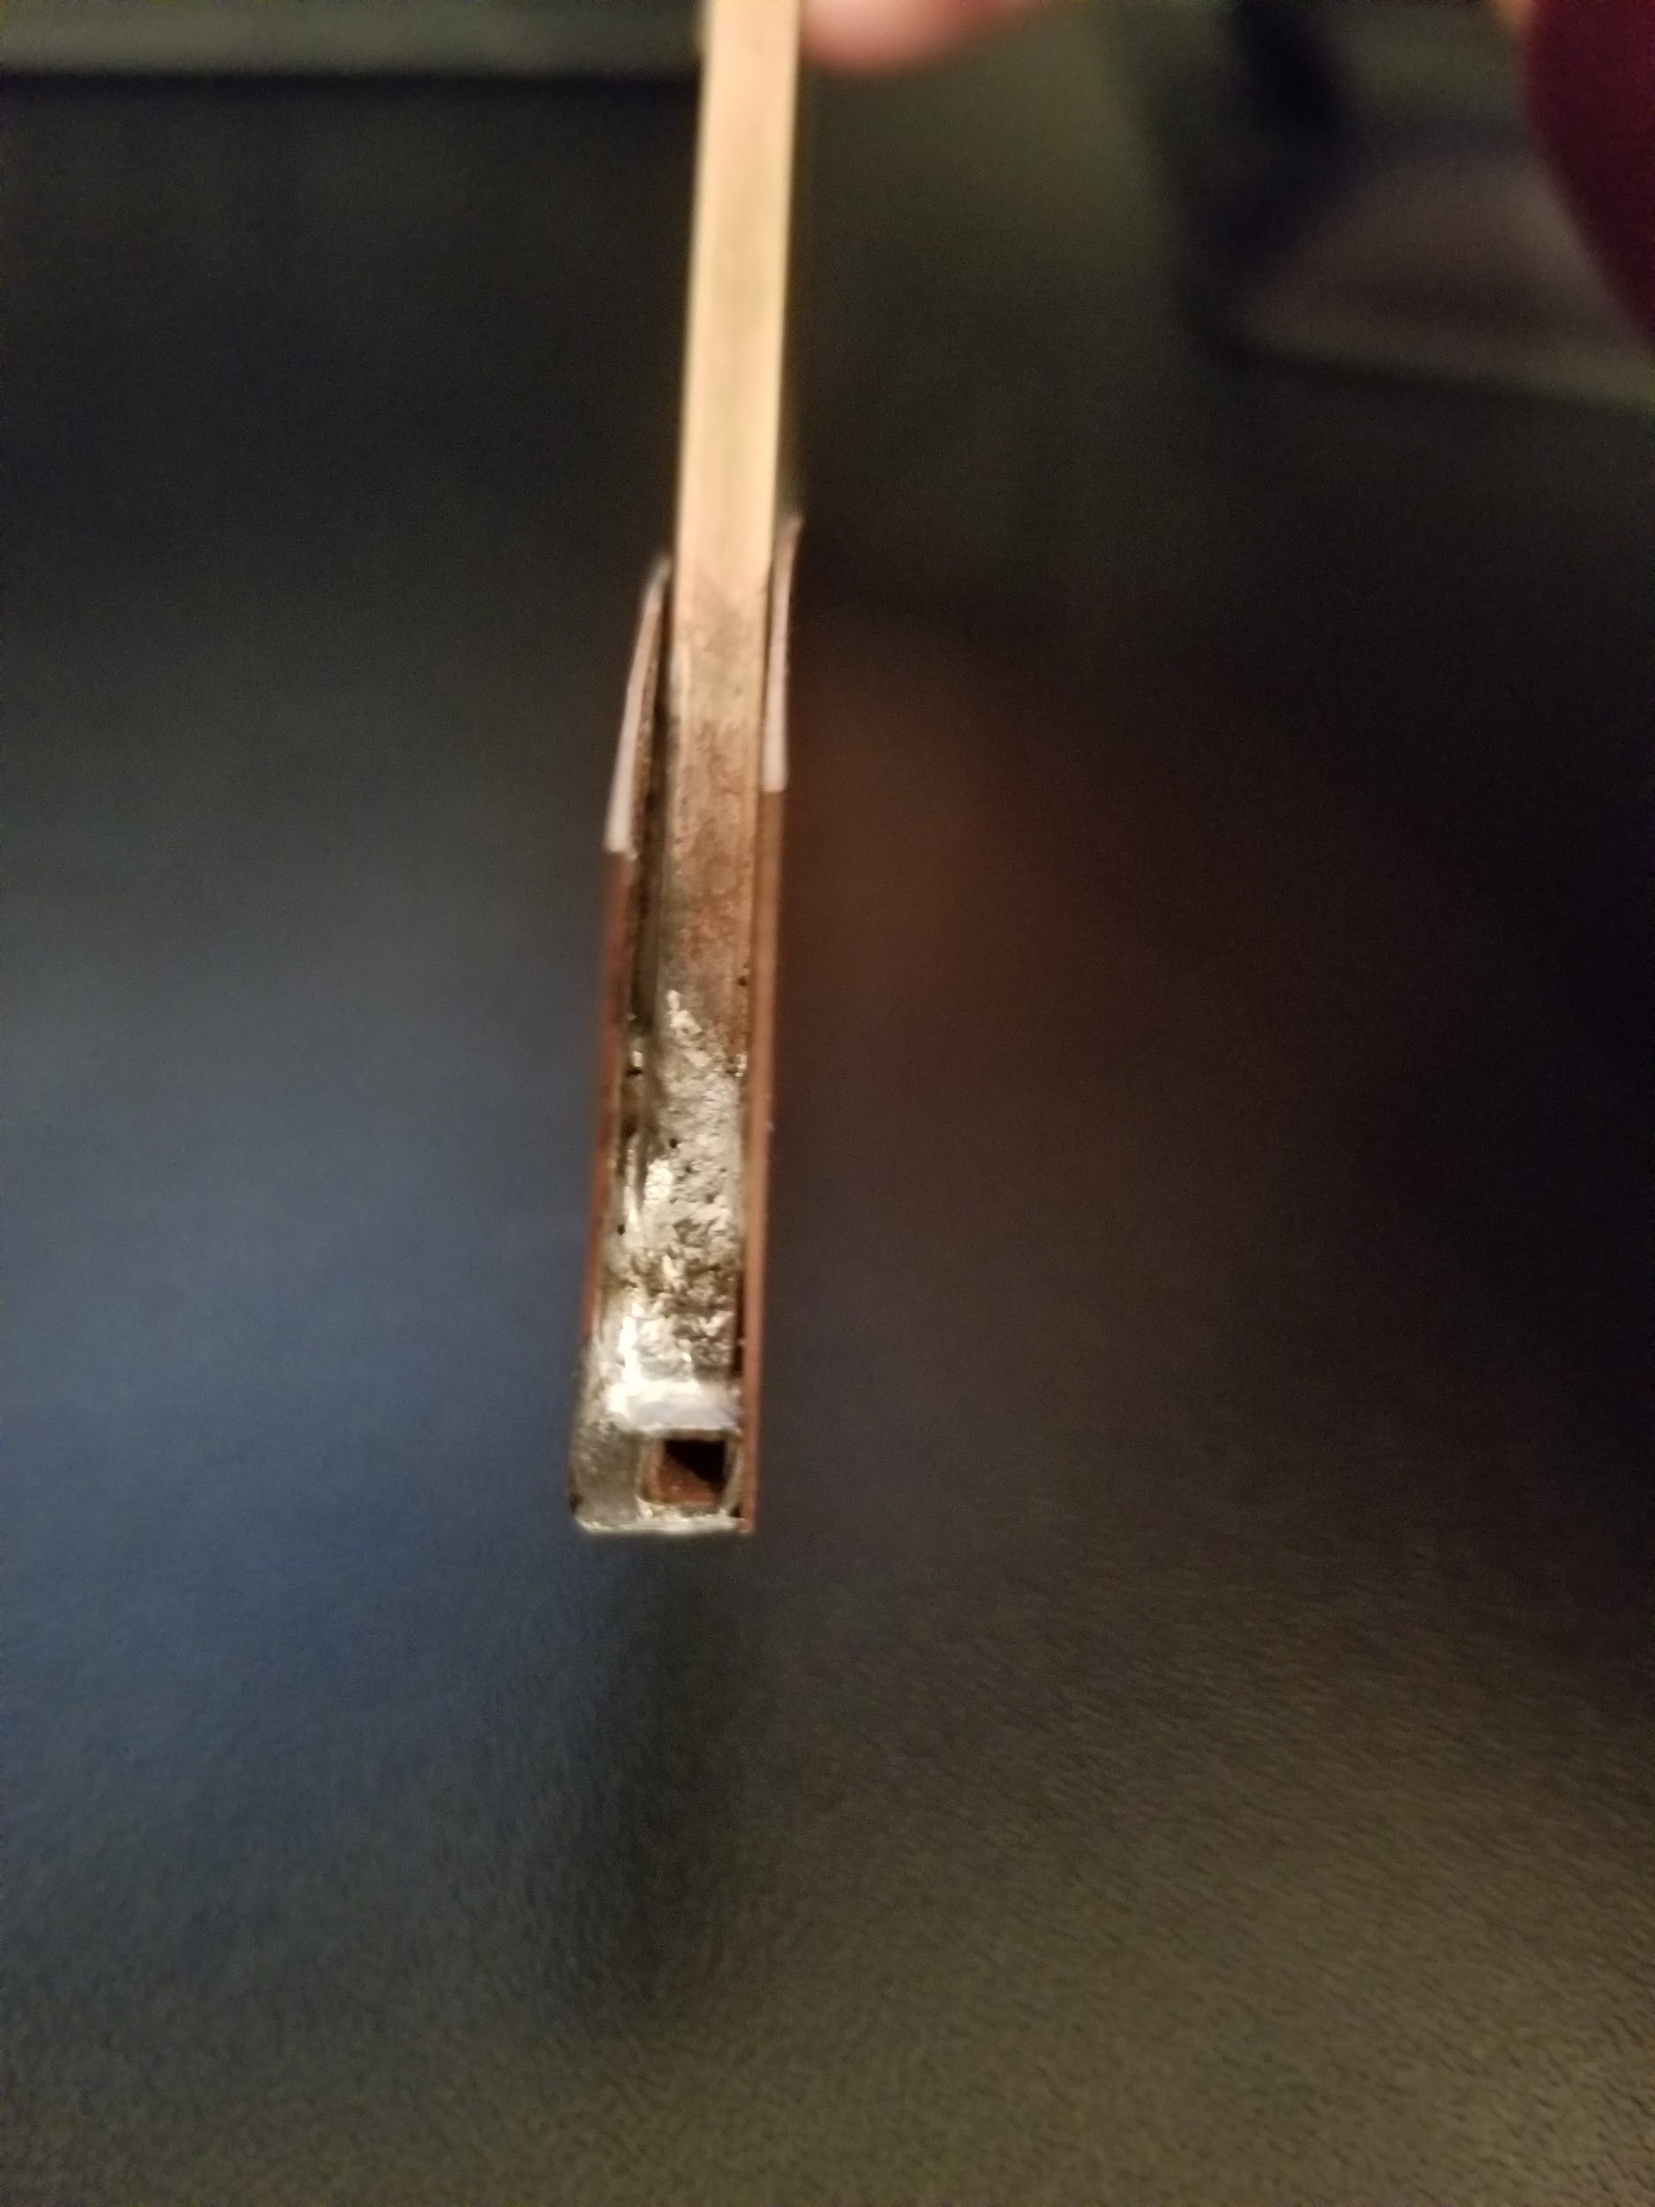

Another failure the team experienced was aligning the members together properly which resulted in all brass members not meeting at the same point which can weaken the strength of the joint. This was most likely the result of using bricks to hold the members down to keep the pieces from moving while being soldered. When placing the bricks some members did move slightly and across multiple joints this misalignment was magnified resulting in 2 joints having members that do not all meet at the same point (A7).

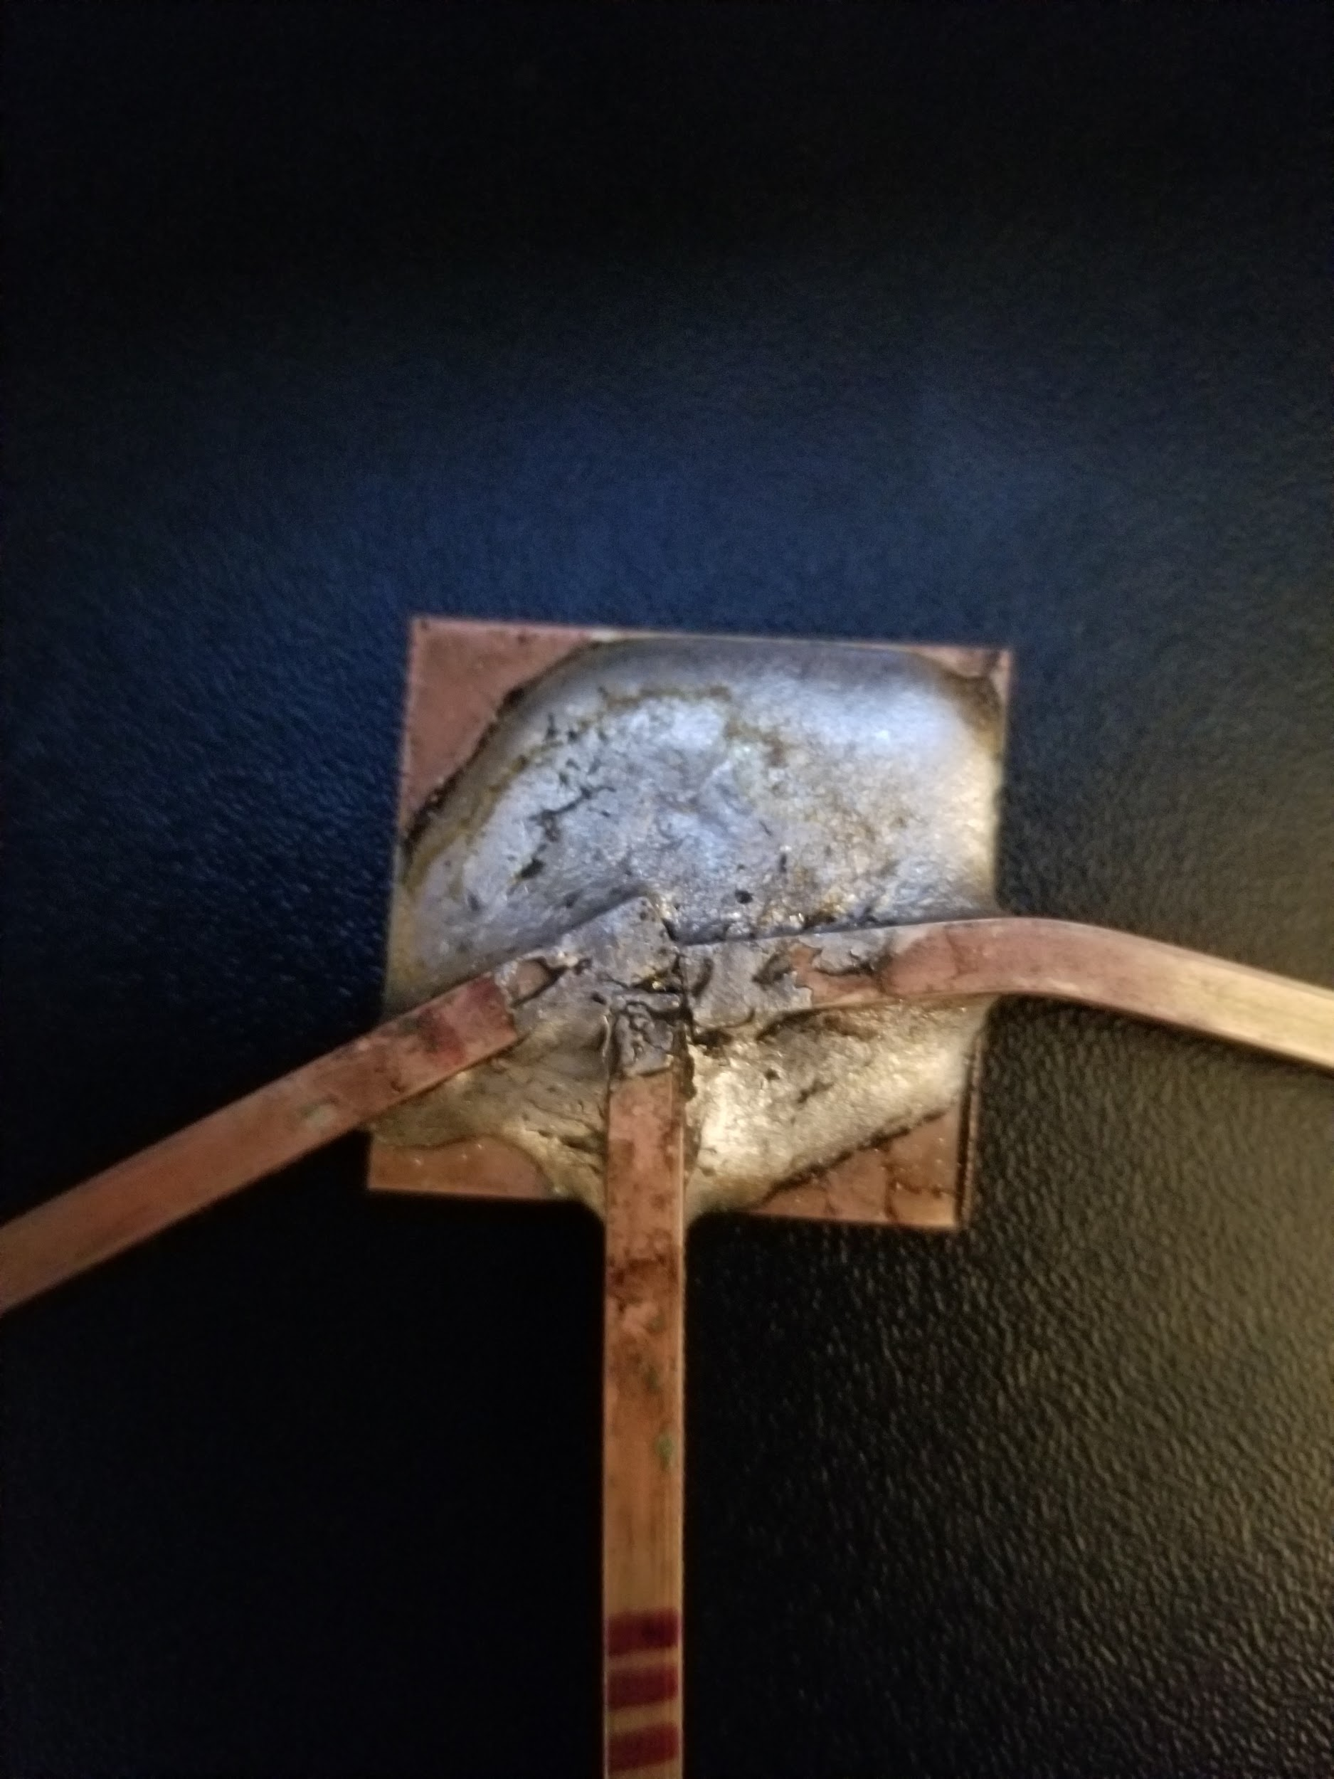

The third reason for failure was due to the fact that during the construction of the top joint of the truss, there was excess solder added to the top where the load was applied. After testing, cracks had developed in solder (A8). This opens the possibility that the solder could have cracked during loading causing the loading device to shift to the left, resulting in a redistribution of the loading causing the truss to fail preemptively.

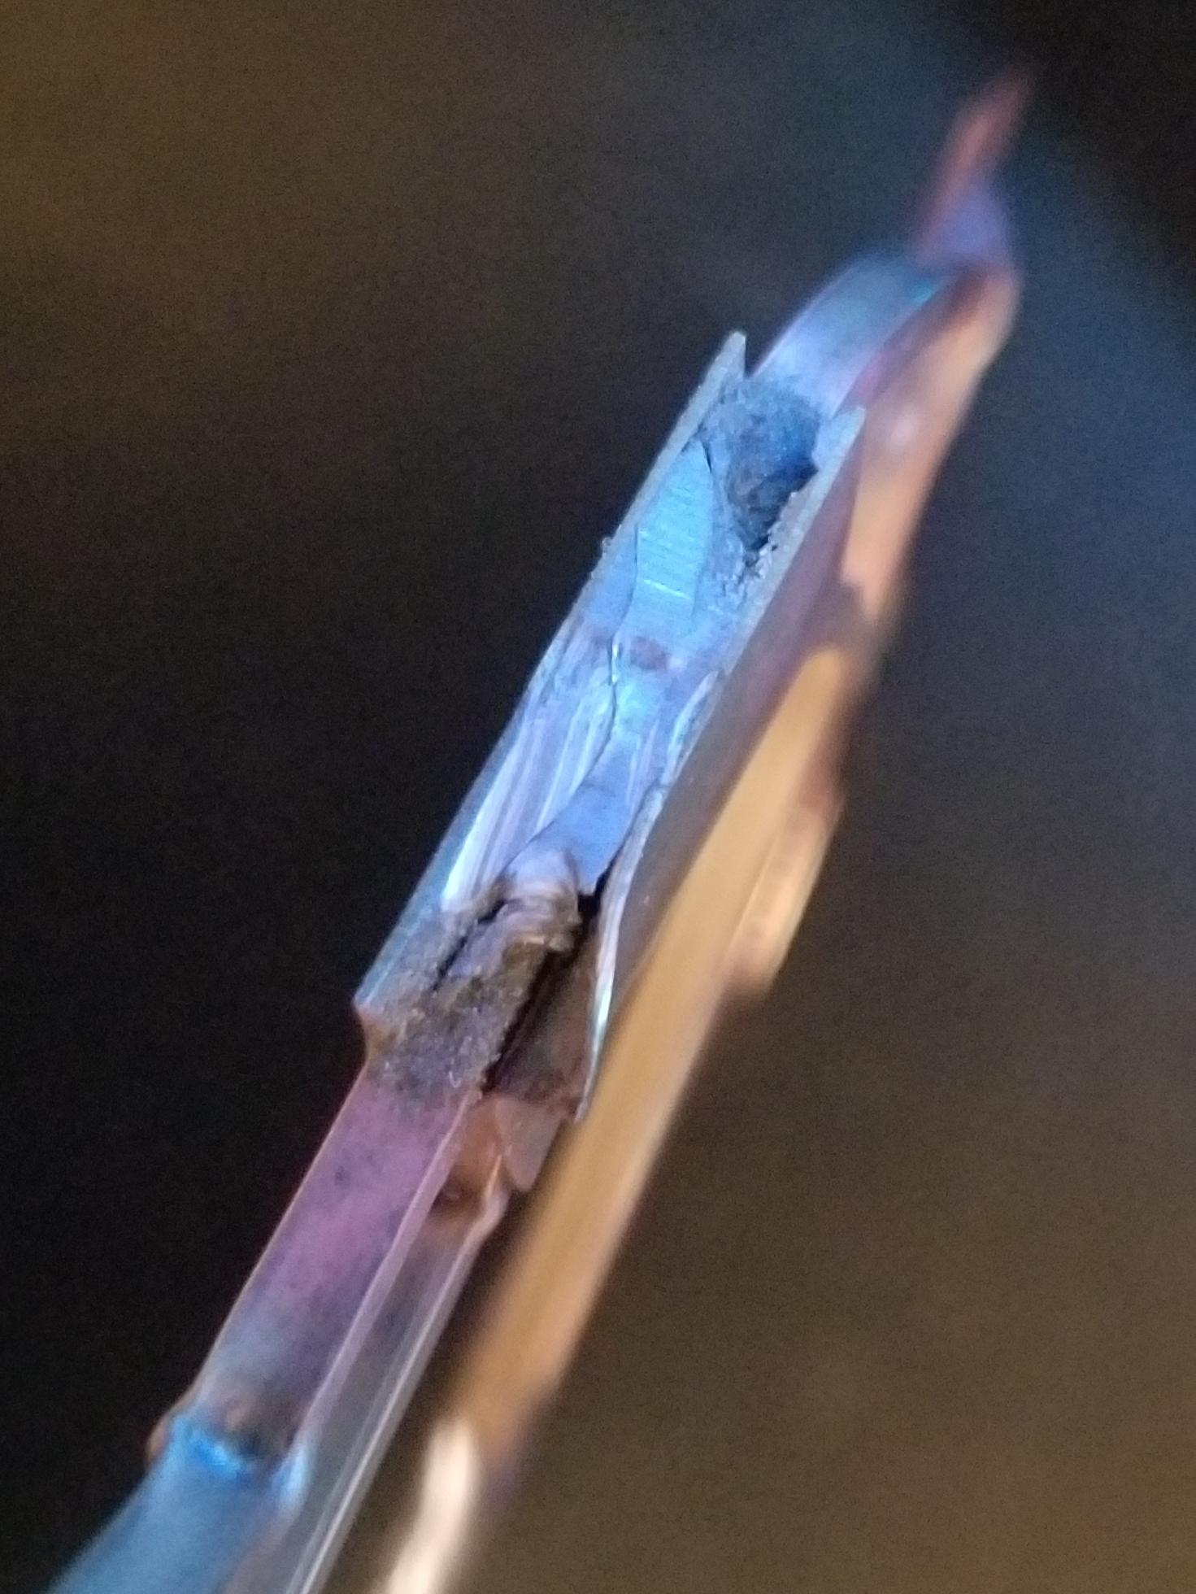

When determining which member failed first the group first looked at the models predicted members to fail. The predicted members to fail were members 3 and 6 and both ended up having less unsupported length because of how the solder was applied. As a result, the actual unsupported lengths of members 3 and 6 were 1.625 inches and 1.875 inches respectfully. Both members ended up being about an inch shorter which caused member 3 to be 2.76 times stronger than expected and member 6 to be 2.07 times stronger. This was calculated by using and simplifying Euler’s Critical Buckling Equation to get the ratio of actual strength over theoretical strength, .

Since members 3 and 6 were stronger than expected, a different member failed. However, when looking at the truss after failure, it is difficult to see which member is the one that caused the truss to fail. As seen in attachment A9, all members meeting where the load was applied buckled or bent in some way.

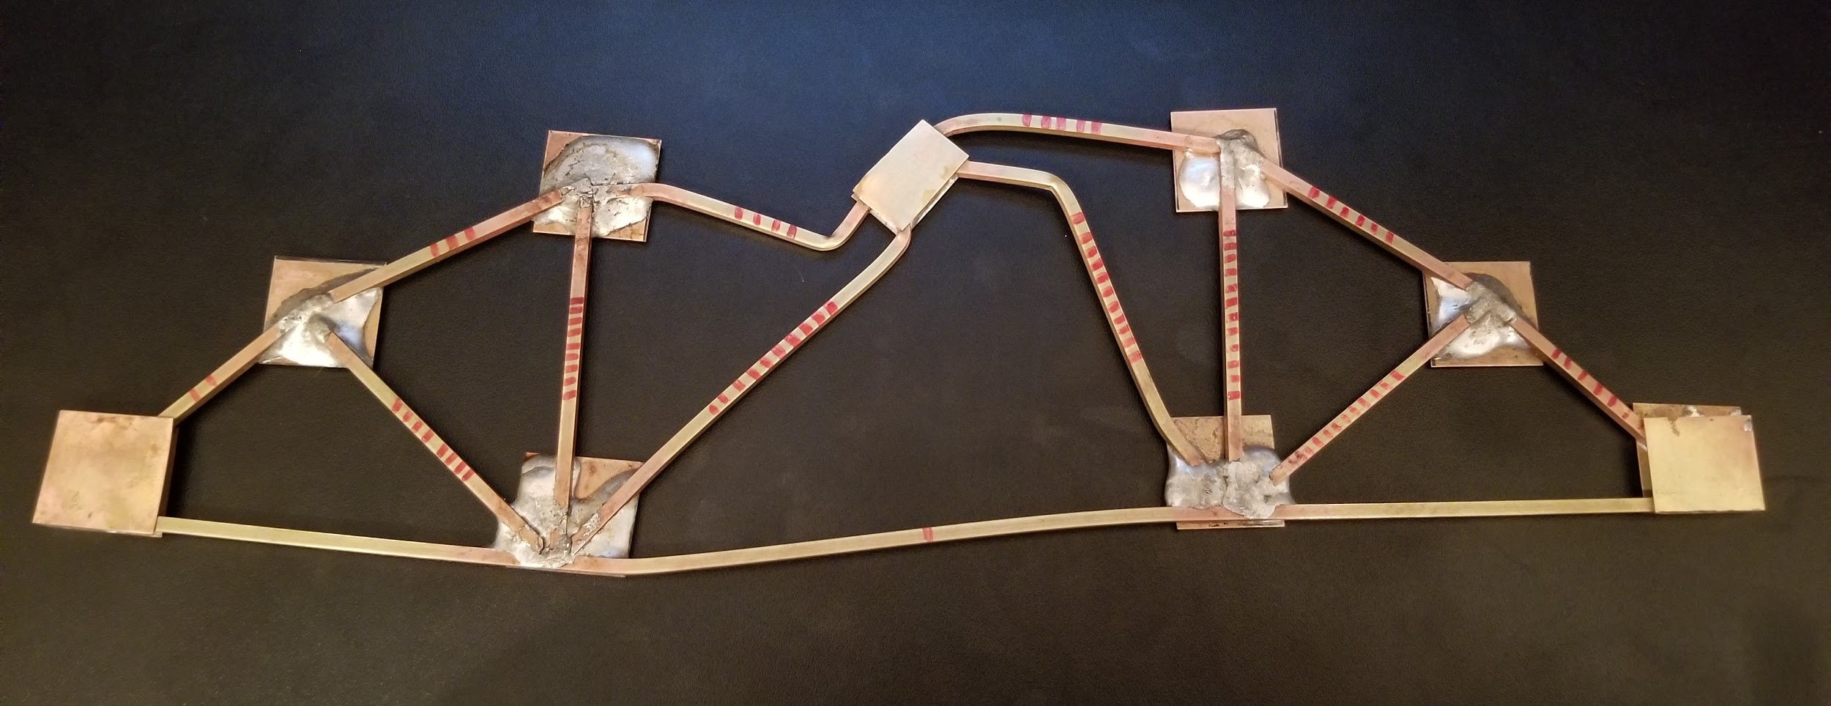

From this, it is conclusive that members 5 and 10 are not the ones that caused the truss to fail due to how they bent. Both members are bent very close to the point of loading and their bending is smooth, compared to members 4 and 11 whos bending is sharper and further from the joint. At failure, the loading device slipped and slid to the left causing the device to bend member 4, making it difficult to figure out which member, 4 or 11, failed. In order to find out which member failed, members 4 and 11 needed to have their unsupported length measured. However, this task was not straightforward because the members were bent, making it impossible to directly measure the unsupported length. To solve this issue the team decided to measure how much of each member in question was supported by solder and subtract that amount from the premeasured length of the member. Upon measuring the unsupported lengths of members 4 and 11, 2.29 inches and 3.65 inches respectfully, and plugging these lengths into Euler’s Critical Buckling Equation member 4 will fail at 345 lbs and member 11 will fail at 135.8 lbs. Using the truss analyzer program to apply a load of 300.2lbs to the model truss the group was able to get the theoretical loads at failure (A10).

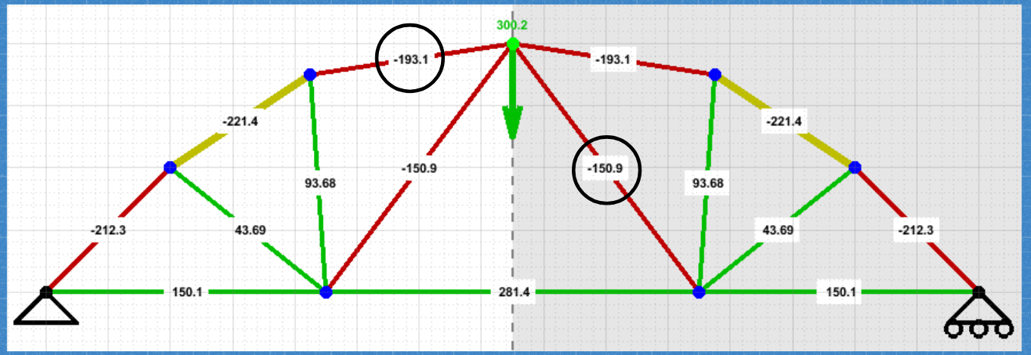

Member 4 has a theoretical load of 193.1lbs and member 11 has a theoretical load of 150.9lbs. Using this the group concluded that member 11 was the member that caused the truss to fail resulting in the bending of member 4 and the cracking of the solder.

The best improvement to be made to the project is to build and test two trusses. This gives each group the opportunity to test an initial design without having to worry about its success, to gain experience and develop strategies for soldering, and to give each group the ability to make improvements to their design by applying what the group learned from their initial truss build be it a success or failure.

Finally, given the opportunity, the group would have spent more time coming up with and practicing techniques for double gusseting because the group didn’t have a strategy on how to double gusset and had to develop and test ideas on the main build. Moreover, the group would have cut the gussets down to help reduce the spread of the solder at the joints resulting in a lighter and better-supported truss.

**Attachments:**

A1. Work Breakdown Structure

|  |  |
| --- | --- |
| Work Breakdown | |
| Truss Designs | Individual Designs-  Trevor Dawideit  Kayla Gorrell  Darren George  Jonathan Joshua  Final Design-  Trevor Dawideit  Sketch-  Kayla Gorrell |
| Fabrication | Cut and Sand-  Kayla Gorrell  Trevor Dawideit  Soldering-  Darren George  Jonathan Joshua |
| Oral Report | Objective-  Darren George  Requirements-  Jonathan Joshua  Design-  Kayla Gorrell  Testing/Final Evaluation-  Trevor Dawideit |
| Written Report | Abstract/Title Page/ToC-  Kayla Gorrell  Introduction-  Darren George  Jonathan Joshua  Discussion-  Kayla Gorrell  Trevor Dawideit  Conclusion-  Trevor Dawideit |
| Project Management | Kayla Gorrell |

A2. First Individual Design



A3: Second Individual Design



A4: Final Design 

A5: Analysis Table of Truss Analyzer

|  |  |  |  |
| --- | --- | --- | --- |
| Design | Picture of Truss | Max Load, Length, Strength to Length Ratio | Analysis |
| Kayla’s Individual Design |  | 327.8 lbs  61.25 in  5.35 | Pros of the design is that it has a small total length giving it a better strength to length ratio. Cons of the design is how it holds only the minimum and that there are members that don’t support any force, therefore a waste. |
| Trevor’s Individual Design |  | 355 lbs  62.17 in  5.71 | Pros of this design is its ability to hold so much while keeping length low. The arch design distributes weight seamlessly and the strength to length ratio is ideal. The cons of this design are the multiple connections with the base, causing excess length to be used. |
| Darren’s Individual Design |  | 350 lbs  79.1 in  4.42 | Pros of this design is the ability to hold 25 lbs more than the minimum. The cons are that it uses over the maximum amount of length, it has a low strength to length ratio and there’s a lot of joint connections that gives a lot of opportunity to make mistakes. |
| Jonathan’s Individual Design |  | 300.3 lbs  69.95 in  4.29 | The pro of this design is that it uses less than the maximum length of 72 in. The cons are that the design doesn’t hold at least 325 lbs, the strength to length ratio is not ideal, and there’s a lot of joint connections. |
| Final Design |  | 346.2 lbs  56.06 in  6.18 | Pros of this design is that it meets all requirements with room for error. Implementing the two main joints (from the first design) on the base kept total length low and the arch design (from the second design) distributed weight through all the members. The one con is that 5 member joints are hard to solder and the angles need to be accurate to ensure the success of the truss. |

A6: Double Gusset Joint



A7: Soldered Joint



A8: Cracked Solder



A9: Truss Post Test



A10: Truss Analyzer with Real Loading



A11: Brass Compression Data

